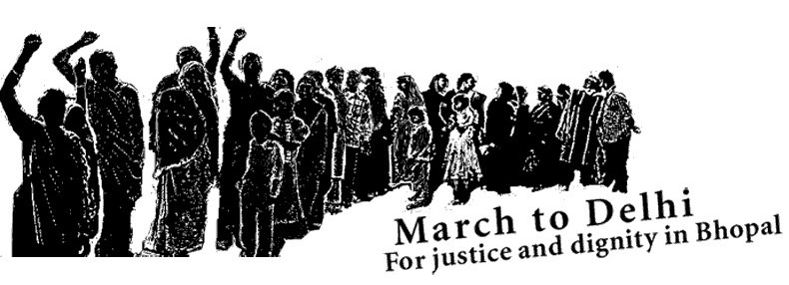

PRESS NOTE

STATEMENT OF SUPPORT

Delhi Groups Express Support for Bhopal-Delhi March by Carbide Gas Victims

21 February, 2006, New Delhi: Human rights and environmental groups from Delhi pledged their support to the 150 survivors of the December 1984 Union Carbide disaster in Bhopal who on 20th February set off on a 900-km march on foot to New Delhi demanding justice and a life of dignity for the people poisoned by American multinational Union Carbide Corporation. The march led by four Bhopal-based organizations will also include people affected by ground water contamination from Union Carbide’s abandoned factory in Bhopal. The Delhi groups said “It is shameful to see the Indian Government facilitating the business of Union Carbide and Dow Chemical while the problems caused by the 1984 gas leak remain unaddressed. The Prime Minister should meet the survivors and ensure that every one of their demands is speedily met.” Worldwide, students and other supporters will demonstrate at Indian embassies and send letters to the Prime Minister in support of the Bhopalis demands.

In Delhi, supporters will organise marches, vigils and student groups will organise plays to highlight the failure of the Indian Government to protect the victims of the world’s worst industrial disaster. They will also participate in a massive letter writing campaign directed at the Prime Minister to press him to meet the survivors and accede to their demands. “Bhopal is of relevance to all of us. More than anything else, Bhopal exposes that the Government is there only to protect the rich. It will spend crores to build a shipping channel or a desalination plant, but it is unable to find the resources to deliver water to 20,000 people in Bhopal who are currently forced to drink water poisoned by Union Carbide’s toxic wastes,” the Delhi groups said. The most urgent demand in the 6- point charter of demands of the Bhopalis is the supply of piped water from Kolar reservoir in the 16 communities affected by toxic contamination of ground water.

The Bhopal marchers expect to reach New Delhi in the last week of March when they have sought a meeting with the Prime Minister. Depending on the response of the central government the marchers may decide to go on an indefinite fast at the end of their 800 kilometer long march. The four organizations: Bhopal Gas Peedit Mahila Stationery Karmachari Sangh, Bhopal Gas Peedit Mahila Purush Sangharsh Morcha, Bhopal Group for Information and Action and Bhopal ki Aawaaz will present their charter of demands to the Prime Minister.
They have demanded that the Government should set up a National Commission on Bhopal, with participation of survivor organisations, to provide facilities for health care, economic rehabilitation, medical research and social support. Other demands relate to the setting up of a special cell within the CBI to expedite prosecution of Union Carbide Corporation and its former chairman Warren Anderson, assessment and clean up of toxic wastes, and a ban on the Government’s purchase of Dow Chemical’s products, including the toxic pesticide Dursban. The survivors have also demanded that December 3 be declared a National Day of Mourning for victims of industrial disasters and include the disaster in educational curricula.

The route for the Delhi Padyatra has been chalked out with a view to making connections with other pollution impacted communities along the way. The marchers will organize poster exhibitions, film screenings and public meetings to make people aware of the need for justice in Bhopal for prevention of corporate crime everywhere.

Issued By:

Amnesty International-India, Association for India’s Development, Delhi Forum,
Greenpeace, Jan Sangharsh Vahini, Kalpavriksh, Lokayan, Lok Raj Sangathan, National Alliance of People’s Movement, People Tree, Pravah, The Other Media, Urban Labour Organisation, Urban Women Labour Organisation, We For Bhopal

Contact:
International Campaign for Justice in Bhopal
c/o The Other Media
A 1/125 Safdarjung Enclave
New Delhi 110029
Phone: 41652451/52 and 26105472
http://www.studentsforbhopal.org/MarchToDelhi.htm and www.bhopal.net/march

Bhopal Gas Peedit Mahila Stationery Karmachari Sangh
Bhopal Gas Peedit Mahila Purush Sangharsh Morcha
Bhopal Group for Information and Action
Bhopal ki Aawaaz

Demands of the Bhopal to New Delhi Padyatra February -- March 2006

1. National Commission on Bhopal: with the necessary authority and funds to provide facilities for health care, medical research, social support, and economic rehabilitation of the people poisoned by Union Carbide / Dow Chemical and their children at least for the next 30 years. This commission must have active participation of non-government doctors, scientists, and representatives of survivor's organizations.
2. Provide Safe Drinking Water: Commit full funds for and agree to time-bound plan for delivery of piped Kolar Reservoir water to communities affected by Union Carbide / Dow Chemical's contamination.
3. Prosecute Union Carbide and Anderson: Set up a Special Prosecution Cell in the Central Investigation Bureau with representatives from the Ministry of External Affairs for speedy prosecution of Union Carbide Corporation, Warren Anderson, and other accused in the criminal case of the December '84 disaster.
4. Make Dow Clean Up and Pay: Ensure scientific assessment of the depth and spread of toxic contamination in and around the Union Carbide factory in Bhopal and make Union Carbide's current owner The Dow Chemical Company pay for the clean-up of toxic contamination and compensation for the health and environmental damage caused by reckless dumping of chemical wastes.
5. Blacklist Dow and Union Carbide: Stop government purchase of Dursban and other Dow products and halt any expansion of Dow's business in India until it accepts the pending liabilities of Bhopal.

6. Remember Bhopal: Include representatives of survivors' organizations in the creation of a memorial to the disaster, declare December 3rd as a National Day of Mourning for Victims of Industrial Disasters and Pollution, and ensure that the Bhopal disaster and its aftermath is included in school and college curricula.

